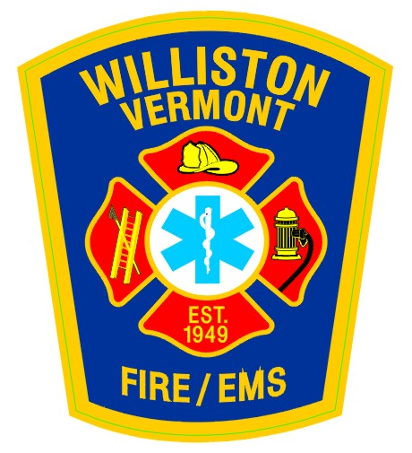

CAREER FIREFIGHTER/EMT

The Williston Fire Department, a combination career/call Department located in Chittenden County, Vermont, has one (1) full-time opening for the position of Career Firefighter/EMT. Minimum qualifications are Firefighter II, AEMT, and current CPAT certification. Paramedics are encouraged to apply, as we are in the process of exploring transition to a Paramedic service.

We are looking for a self-motivated, detail oriented, dedicated individual to serve on our Fire/EMS career team. The candidate must have a strong work ethic, Fire and EMS experience, and a clean driving record. This individual will work as a member of the career staff while assisting with the development of our call staff.

Duties will include, but are not limited to:
- Response to fire and emergency medical calls within the Town of Williston and to surrounding mutual aid communities.
- Working with the Fire and EMS call staff to include scheduling, tracking certifications and training requirements, and ensuring shift requirements are being met.
- Participate in Fire and EMS training events and in the development of lesson plans.
- Assist with fire prevention and public education programs.
- Administrative and operational duties associated with daily firehouse operations.

Career staff work a 24-hour on / 48-hour off shift schedule which includes nights, weekends and holidays. Salary and benefit information is available upon request via e-mail to admin@willistonfire.com. This is a new position with an expected start date of July 1, 2016.

Please send resume and cover letter by May 1, 2016 to:
Chief Morton, Williston Fire Department, 645 Talcott Road, Williston, Vermont, 05495

Williston Fire is an equal opportunity employer.

04/04/2016

